**Summary Report #2**Andrew Randell, Fan Kang, Lovdeep Singh & Maral Mohagheghi

**Progress**

Throughout the past three weeks, our group has worked on building prototypes and testing possible solutions to aspects of the design challenge. We began our prototyping efforts by building a strong 4 wheel chassis, as we wanted to ensure that our robot would be able to move over the obstacles in the power plant in a stable manner. We built multiple possible pyramid pickup mechanisms using the VEX parts available in the lab to test the validity of our designs. We then selected the intake design with the most favourable outcome. After further testing we realized that having one mechanism for both the cube and pyramid pickup was lowering the quality of the two systems, and therefore decided to use separate mechanisms for the cube and the pyramid. A prototype demonstrating aspects of our final product has been completed as of today.

**Prognosis**

Through testing and prototyping various design concepts and sensors, a preliminary final design of the Tesseract robot was developed. We will likely continue to use a strong 4 wheel drive with 4 inch wheels to effectively navigate the field through the use of ultrasonic distance sensors and integrated motor encoders, geared down 4:1 to a higher torque and lower speed. To manipulate the power pyramid, the “roller” design angled perpendicular to the walls of the pyramid was proven to be the leading solution. The cube will be retrieved through sweeping the top of the walls with an arm, sensing for the magnetic field created by the cube through the use of a Magnetometer and hall effect sensor, at which point it will be gripped through a simple claw and conveyed back into the robot. Both intake mechanisms will be built on simple lifts to allow for vertical movement.

**Plan**

1. Finalize CAD of Cube Intake, Pyramid Intake, Lifts, and Chassis.
2. Laser-cut appropriate features, such as the pyramid intake and cube claw.
3. Write base function operation:
   1. Follow the perimeter of the sample field located in the MSE lab
      1. Ensure the device can negotiate the conduits and 90 degree turns while maintaining stability. Three ultrasonic sensors will primarily be used to achieve this task.
      2. Two Left-mounted ultrasonic sensors will continuously be sampled by a secondary controller[1]. The values will be transmitted to the main controller via a Serial UART connection[2]. The received values will be kept equal within a tolerance by the main controller to ensure the device maintains a parallel trajectory with respect to the outer wall.
      3. A third Front-mounted ultrasonic sensor will be used to identify an appropriate turning distance. This will also be sampled by the secondary controller and transmitted via the same Serial UART connection.
   2. Identify the cube via a selection between or combination of a 3-axis Magnetometer, Hall Effect Sensor, and Reed Switch. Retrieve Cube.
      1. Scan the perimeter of the field for magnetic interference on any-one of the sensors mentioned above.[3]
      2. When interference is detected, proceed to intake the cube
   3. Identify the correct pyramid via the correct carrier-frequency received by the infrared sensor.
      1. Scan the field for the correct carrier-frequency by rotating robot on its axis.
      2. Proceed in the direction of the correct frequency until the limit-switches in the Pyramid intake are send an interrupt request to the main controller.
   4. Place Cube under pyramid
      1. Place Cube on the ground
      2. Orient the device such that the cube is towards at the rear.
      3. Place pyramid on top of the cube.
4. Debug and ensure the device can perform the tasks above sequentially without requiring a human to intervene.
5. Complete the task at the showcase.

**Appendix**

**Finalized Chassis Design**

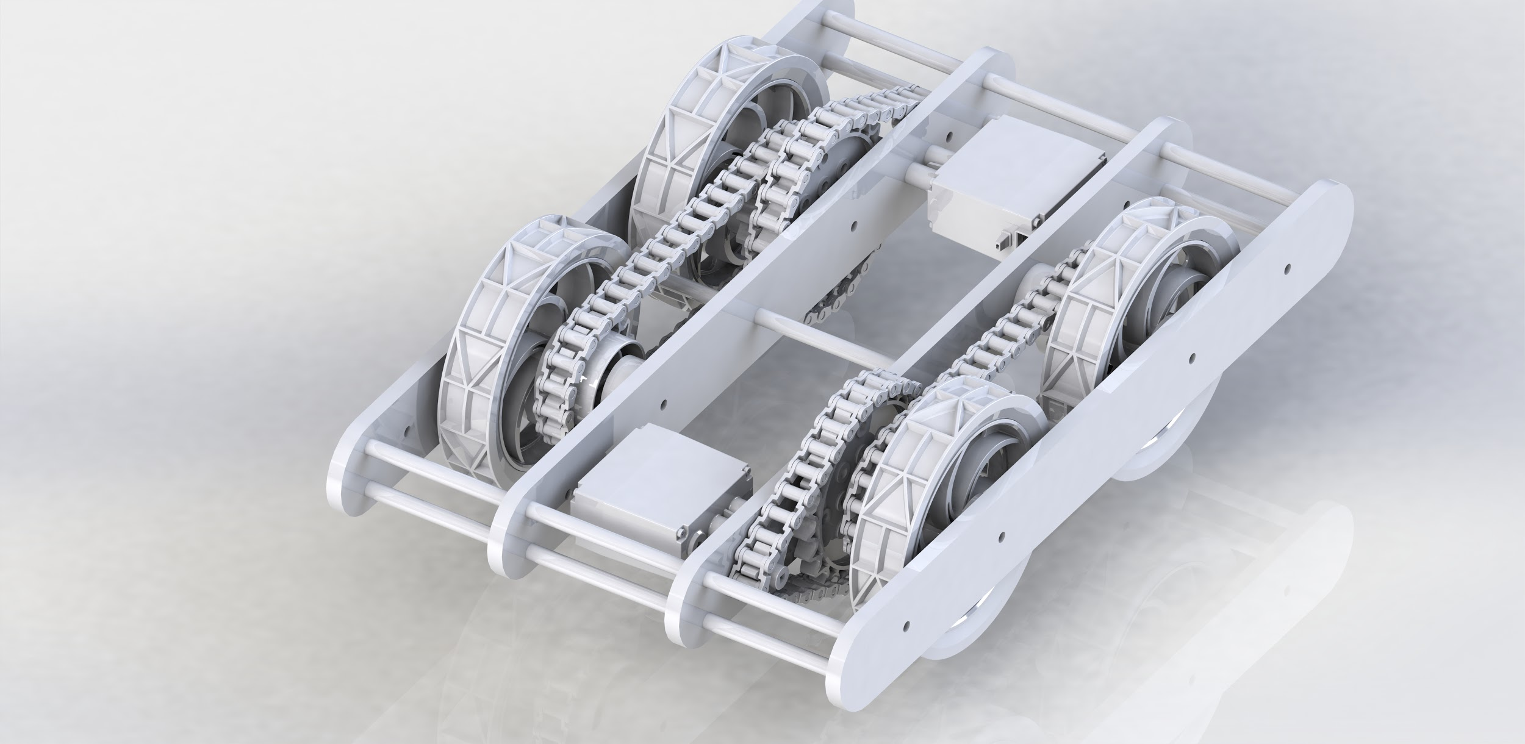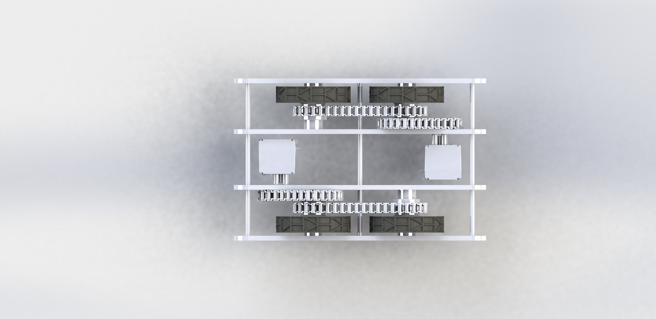

**Block Diagram**

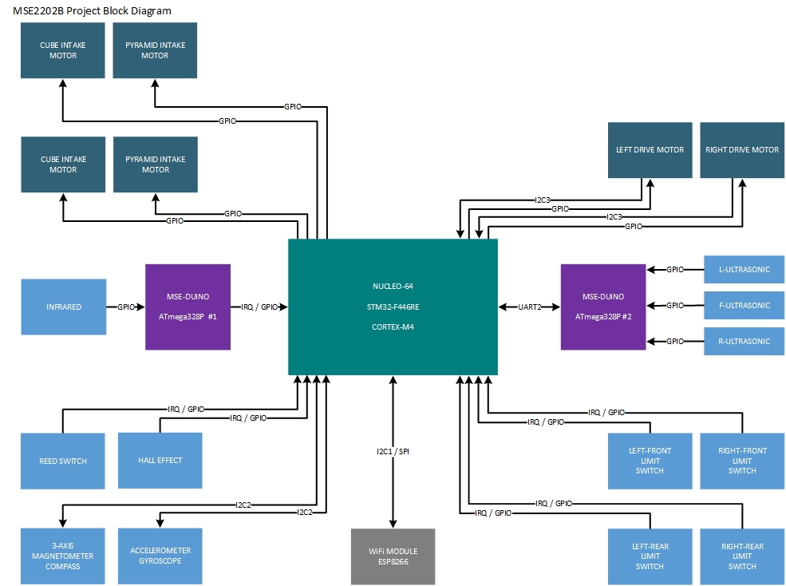

1. Secondary controller used to prevent the use of blocking-functions on the main controller.
2. Data will be transmitted via comma-separated values and parsed on-the-fly via the main controller. Refer to the Appendix for a complete block diagram of the electronic components.
3. If this task becomes too inconsistent, revert to our secondary concept for retrieval of the cube.